**POLYTECHNIC UNIVERSITY OF THE PHILIPPINES**

College of Engineering Department of Computer Engineering

A. Mabini Campus, Anonas St., Sta. Mesa, Manila, Philippines, 1016

Automated Paint Mixing Machine with Color Detecting Mobile Application

Engr. Julius S. Cansino1, **, Dr. Arvin R. De La Cruz2 **, Jerico M. Clemente3, *, Aldrin O. Dizor4, *, Marife G. Gajelan5, *, Joven R. Sabangan6, *

*\*\*Faculty, *Proponents, Department of Computer Engineering, PUP College of Engineering*

# ABSTRACT

**Colors have been used to communicate actions and influence certain physiological responses from different organisms around the world. With the advancement of science and technology, humans have developed paint, which served as a means to acquire and artificially apply color to different objects and surfaces. Therefore, this study aims to establish an effective system that will simplify the process of mixing paint colors in order to produce a desired color output. In order to create the system, the proponents developed both a machine and mobile application. An image was captured through the application, and the corresponding selected color value is then sent to the machine for processing. The output products of the system are then compared against the actual color value, where accuracy is measured. The system itself is then evaluated by ordinary users and technical specialists via a questionnaire based on the ISO 25010 standard. The accuracies of the mobile application’s color scanning capability, and the output paint color were calculated to be at least 98% and 80%, respectively. Based on the results of the study, both types of respondents gave a generally agreeing score based on the characteristics in the ISO 25010 standard. The mobile application performed satisfactorily as well, and the difference in camera resolution were minute. Furthermore, the output paint color perceived by the users were given an average score ranging from slightly similar to neutral, indicating that the colors were satisfactorily the same.**

***Keywords***: *Paint Mixing, Color Mixing, Color Detector Mobile Application, Polytechnic University of the Philippines, Computer Engineering*

# INTRODUCTION

Colors are used as a form of communication to invoke different emotions or signs in the readers. It can be used to distinguish between nearly identical objects, such as those from a traffic light, and signal a different meaning. The human eye can differentiate exactly three different colors; however, the brain can interpret these in multiple ways. A typical application of using colors is paint — which is essential in giving color to one's room. It also provides a protective coating that preserves either or both exterior and

interior surfaces. This helps the surface where paint is applied to withstand erosion while at the same time protecting it from damages that extreme weather conditions may cause. Another importance of paint is that it helps set the mood for someone in the room seeing it. It is said that rooms with light-painted walls tend to put people in a happier mood instead of rooms with dark-painted walls that negatively affect people's attitudes. Therefore, determining the right color for the context will help convey the correct meaning and avoid misunderstandings.

The paint mixing process has been steadily improving ever since fred a. Schletz invented the paint-mixer in 1932, which was then called the "shakers." (peiken, 2003) as the world continues to evolve, many paints mixing machines have also surfaced on the market. However, paint mixing is an entirely different process compared to color picking. Color picking is crucial when someone wants to choose a specific color or shade for their surface; hence making one slight error may compromise the whole process. This can be avoided with the help of technology in the form of a digital color picker — which people will be able to utilize by using their smartphones.

Smartphones have changed people's lives. And as time goes by, this revolutionary technology keeps getting more innovative and better. With the use of mobile applications, smartphones can do almost everything. With the advancement of technology and the dominance of the smartphone industry, mixing paint colors to get the desired design does not need to be time-consuming and inaccurate. Trial and error in getting the right color can fail, wasting the paints, money, and time spent on it.

From the problems stated above, the proponents developed this project of an automatic paint mixing machine with a multifunctional color selector mobile application. The time-consuming estimation of the amount needed to mix the paint color and having a hard time manually mixing the paint color causes a waste of money will be solved. Furthermore, the proposed machine is integrated with a tailored mobile application. The mobile application will help the user scan and select their desired color precisely and accurately through machine vision technology. This will also help the user have an idea of the recommended colors in the captured image by the phone’s camera.

# METHODOLOGY

* 1. **Research Design**

For the development of the machine, the action paradigm was used, along with a modified agile methodology for continuous development. For the evaluation of the system’s characteristics, the descriptive paradigm was used to collect data from different respondents.

The proponents used the Input-Process-Output (IPO) model to represent the system. The model consists of three categories, the input, the process, and the output. The input category is defined as the requirements or data needed from the environment. The process describes the computations and steps taken to transform the inputs. And lastly, the output is the product of those processes (Canonizado, 2021). Figure 1 displays the different variables in the study and the categorization made by the researchers. The inputs mainly include hardware and software components, the process utilizes the agile methodology, and the output is the working prototype of the system. There is also a feedback system, which was used to improve the variables based on the outcome of the feedback.

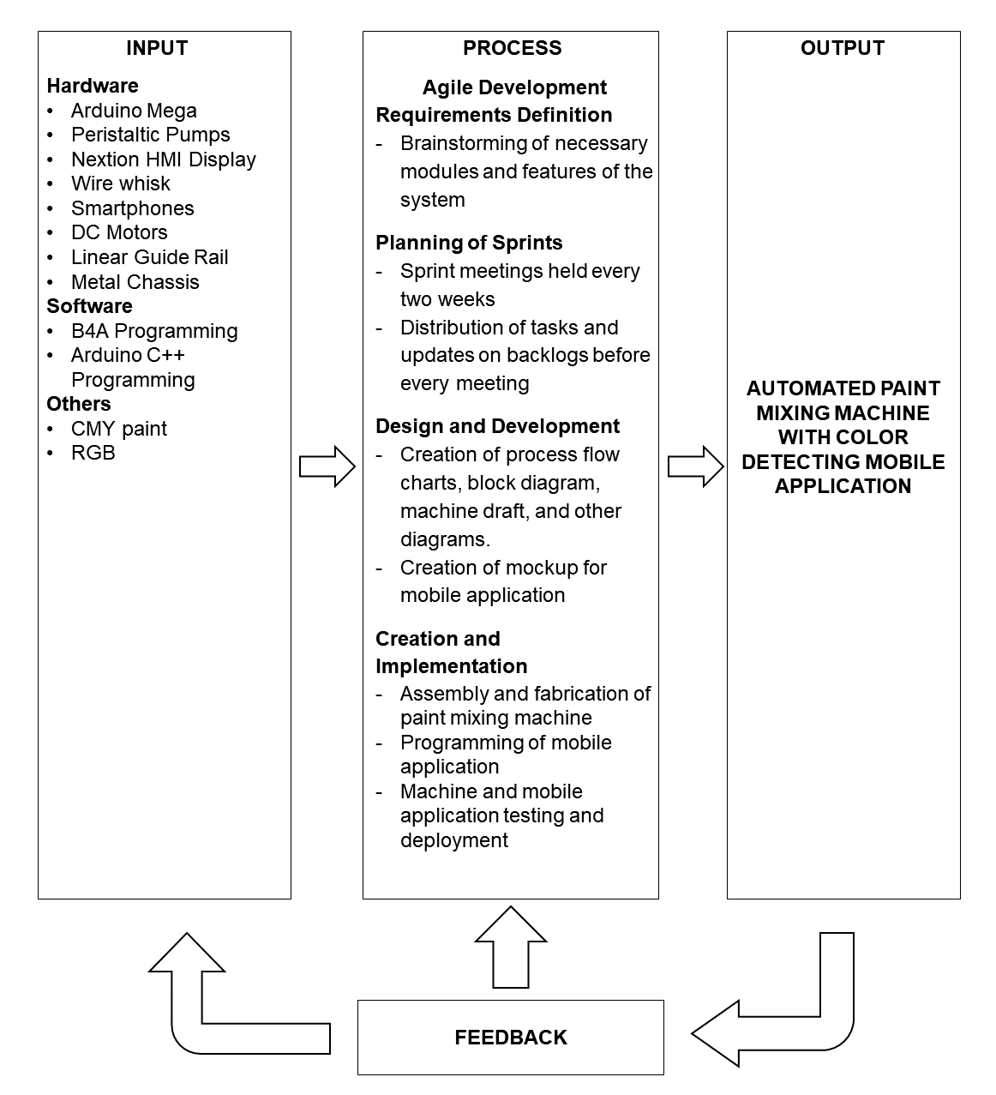

## Figure 2.1.1. Input-Process-Output (IPO) Model

The process category contains the development method the researchers used in creating the system, which is the agile methodology. The agile methodology, which is a software development life cycle, is adapted to fit the project. Continuous iterations of development and testing for the duration of the project is the main principle in agile methodology (Srivastava et al., 2017). Under this, there are sub-methods that implement the principles of agile, and one of these is the scrum. The scrum methodology divides the development into sprints, where each sprint tackles a specific set of tasks and creates a usable product. The researchers proposed a two-week sprint cycle, and at the start of every sprint, the tasks were distributed and finished tasks were reported.

The proponents hypothesized that the system is capable of producing the output paint color that is perceivably similar to the actual input color based on the users’ evaluation. It is also hypothesized that the evaluation based on the ISO 25010 standard characteristics between the two types of respondents bear no statistical difference between their mean. It is assumed that the mean scores between the respondents are similar, indicating a unified evaluation of the machine.

* 1. **Data Gathering**

In order to acquire data to answer the problem statement, the researchers performed experimentations to test the system under various conditions as well as surveyed users using a questionnaire.

The experimentation included the testing of both the mobile application and the paint mixing machine. For the mobile application, sets of images were captured using different camera resolutions, particularly, 13 MP, 19 MP, and 64 MP Android cameras. The images were then processed by the application, and five different pixel points on the images were selected. The acquired CMY values for these points were recorded and compared to the actual CMY values of the pixels using the percent accuracy formula. This comparison allowed the researchers to gauge the accuracy of the mobile application in detecting the color of the pixel on the image. For the paint mixing machine, various color values were sent to the machine via Bluetooth to be processed, and the resulting output paint is then compared against the actual color values.

The survey was conducted both virtually and physically due to the current constraints. The respondents were generally divided into two groups, ordinary users of paint products, and the technical specialists who have knowledge in technology. The questionnaire used in gathering the data consists of characteristics based on the ISO 25010 standard, and a perceived color comparison question. The questions are in the form of Likert scale, and the data was statistically treated using the Welch’s T-test to determine statistical significance.

* 1. **Software Application**

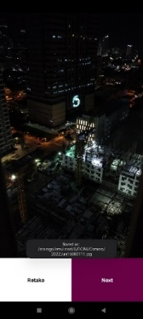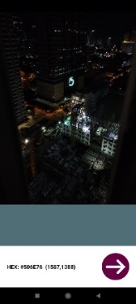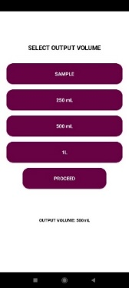

(a) (b) (c) (d)

***Figure 2.3.1. Mobile Application User Interface***

Figure 2.3.1 shows the major user interfaces in the mobile application. First, the user is given a choice between taking a live photo that will open the camera, or select a photo from their gallery (Figure 2.3.1.a). If the user opts to take a live photo, the camera application will open up and the user is able to capture an image. Once an image has been captured, the user can then proceed to the next step or retake an image (Figure 2.3.1.b). After selecting an image, either through live camera or the gallery, the user will then proceed to the pixel selection stage, where they can select a point in the image. The point is a pixel on the image, and the hex color value, as well as the coordinates of the pixel, is then displayed (Figure 2.3.1.c). Once satisfied with the color, the user then proceeds to the selecting the amount of paint to be dispensed (Figure 2.3.1.d). After the user proceeds, the information is sent to the Arduino Mega in the machine via Bluetooth connection.

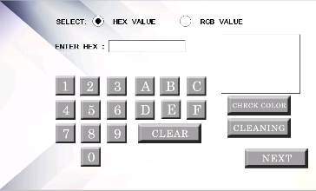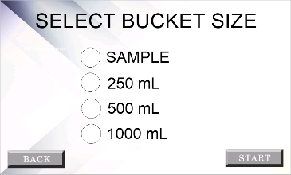

(a) (b)

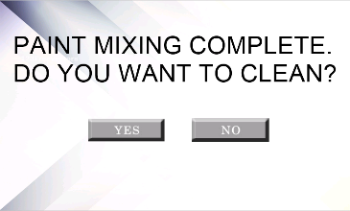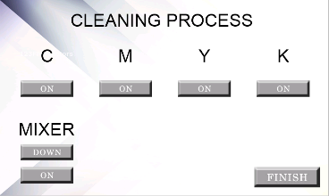

(c) (d)

***Figure 2.3.2. Nextion LCD User Interface***

The figure above displays the major interfaces for the Nextion touchscreen LCD. The device allows the user to manually input their desired color. The user is allowed to input either hex value or the RGB values using a custom virtual keypad (Figure 2.3.2.a). They are also allowed to go directly into cleaning mode. Similar to the mobile application, the user has a selection of output paint sizes to choose from (Figure 2.3.2.b). After the machine has completed the mixing process, the user is prompted whether they desire to undergo the cleaning process (Figure 2.3.2.c). It is important to note that the user should proceed with the cleaning process on a regular basis to avoid the drying of the paint inside the tubes. The cleaning process involves the manual activation of the pumps and the mixer, assuming that the input paint buckets are replaced with water for cleaning (Figure 2.3.2.d).

* 1. **Hardware Components**

The figure below shows the CAD design of the machine. The largest dimensions are 24 inches by 24 inches by 30 inches.



(a) (b)



(c) (d)

***Figure 2.4.1. Computer Aided Draft Design of the Prototype***

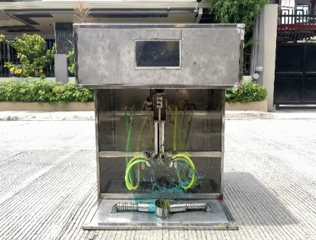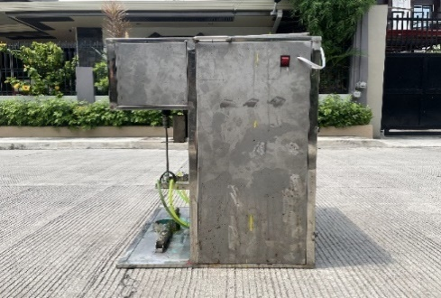

(a) (b)

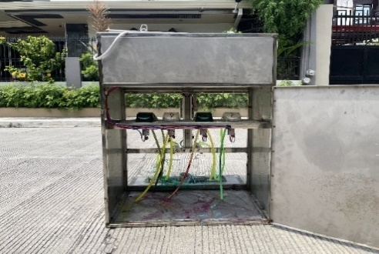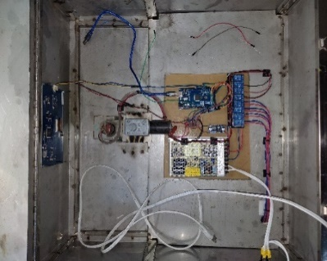

(c) (d)

***Figure 2.4.2. Actual Machine Prototype***

Shown in Figure 2.4.2 is the actual machine prototype. The machine is made from stainless steel to prevent corrosion. The front has a transparent plastic shielding, making it possible to view the pumps and the paint buckets. The level hose connects the input paint buckets to the pumps and out into the mixing container. The side of the machine has a rocker switch that enables powering the machine on and off (Figure 2.4.2.b). The back side has a compartment that holds the input CMY paint buckets, as well as the peristaltic pumps. The top compartment of the machine holds the microcontroller and other electronic components that enables and directs the machine (Figure 2.4.2.d). The major components of the machine include the Arduino Mega, Nextion LCD, power supply, relays, and DC motors.

* 1. **Machine Diagrams**

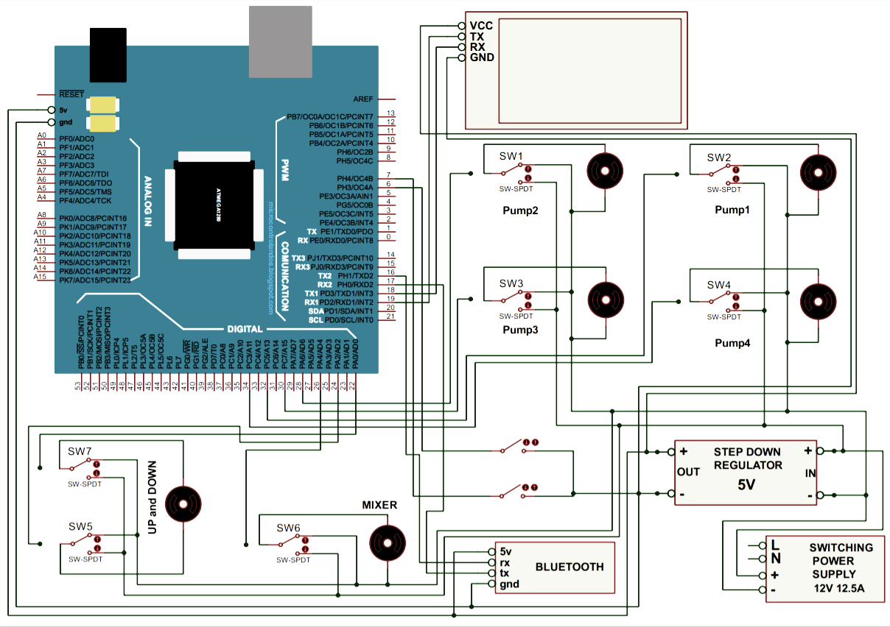

***Figure 2.5.1. Schematic Diagram of the Arduino MEGA to the Other Components***

The figure above presents the machine’s schematic diagram. The 12V power supply is connected to a step-down regulator that transforms the 12V input down to 5V. This 5V is used to directly power the Arduino Mega, which is the microcontroller of the circuit, the LCD, and the Bluetooth module. This is due to the maximum voltage limitation these components can handle, which is 5V. On the other hand, the peristaltic pumps and the DC motors are directly connected to the power supply via relay switches, which receive 12V directly in order to sustain their rotation. From there on, the Arduino Mega uses a 5V supply to trigger the relay switches, turning them on or off depending on its calculations and logic.

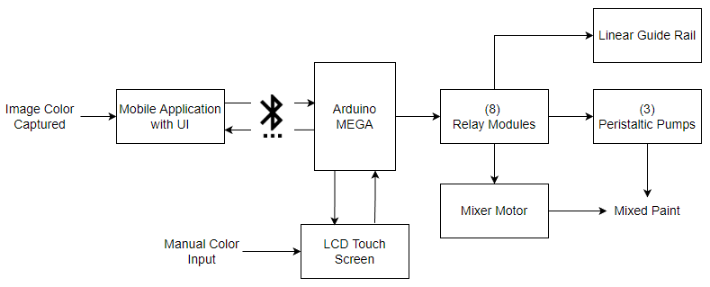

***Figure 2.5.2. Block Diagram of the System***

Figure 2.5.2 above is the block diagram of the machine. Based on the figure, there are two ways to input data into the machine, one via the mobile application, and another one via manual input on the touchscreen LCD. From the mobile application, data is sent via Bluetooth to the Arduino Mega, and the microcontroller is responsible for triggering the relay modules, which in turn activates or deactivates the corresponding component connected to it, which are the three peristaltic pumps connected to the input paint supply, the linear guide rail responsible for the upwards and downwards motion of the mixer, and the actual mixer motor responsible for the rotation of the whisk. After the process, a mixed paint is produced as an output of all the calculations made.

# RESULTS AND DISCUSSION

* 1. **Perceived Accuracy**

***Table 3.1.1. Evaluation of Perceived Accuracy by the Respondents***



In Table 3.1.1, the Ordinary Users (OU) and the Technical Specialists (TS) were tasked to compare two colors, the actual input color and the output paint color of the system. The respondents were not given the color values, and instead used their perception to rate the similarity of the two using a Likert scale. The colors compared were chosen at random. The ordinary users gave average scores of 4.51, 4.46, 3.95, 3.71, and 3.49 for each sample, respectively. Meanwhile, the technical specialists conferred average scores of 4.33, 4.00, 3.67, 3.50, and 3.33 for each sample, respectively. The overall scores were interpreted, ranging from a slightly similar interpretation to a slightly dissimilar interpretation. Particularly, the last two colors comparison items scored a slightly dissimilar interpretation, the third item acquired a neutral similarity, and the first two items gathered a slightly similar interpretation result.

Based on their overall scores, the ordinary users score was interpreted to be having a slightly similar perception, while the technical specialists score was interpreted to be having a neutral similarity based on all samples. The data from this survey was then subjected to a Welch’s T-test, obtaining a t-value of 0.9103. The degrees of freedom (df) of the sample is six, and the critical value is 2.447. Because the t-value is less than the critical value, the researchers fail to reject the null hypothesis. This indicates that there is a general agreement between the two groups of respondents on the perceived similarity of the colors.

* 1. **Color Detection Accuracy**

***Table 3.2.1. Mobile Application Color Detection Accuracy***



In Table 3.2.1, two images were taken at similar settings, each using a different camera resolution. Five different pixel points on the image were selected at random, and the detected color values were recorded. These values were later compared to their actual color values to determine the accuracy. The 13 MP resolution acquired an average accuracy of 99.19% and 99.22% for each of the images. The 19 MP resolution obtained an average accuracy of 99.45% and 99.35% for each of the images. And lastly, the 64 MP resolution received an average accuracy of 99.90% and 99.79% for each of the images. Overall, all average accuracies were above 99% when compared to the actual color values.

* 1. **Scanned Color vs Output Paint Color**

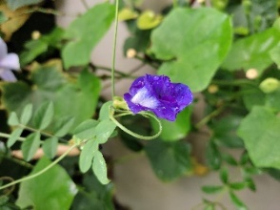 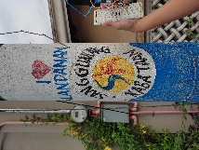

(a) (b)

***Figure 3.3.1. Images Used for Comparison***

The images above were captured through the mobile application using a 13 MP camera resolution with similar lighting conditions. These are used for the comparison between the color detected and the output paint color.

***Table 3.3.1. Comparison Between Color Detection And Output Paint Color for Figure 3.3.1.a***



***Table 3.3.2. Comparison Between Color Detection And Output Paint Color for Figure 3.3.1.b***



The two tables above summarize the results of the comparison between the scanned color and the output paint color of the system. For each of the figures in Figure 8, five pixels were randomly selected on the image. The coordinates of these pixels were recorded, along with the color values detected. The color values were sent to the machine to undergo the mixing process to create the colored paint. Once the mixing process is completed, the paint is then applied to a white paper, and then dried. After which, the color values between the scanned color and output color were then compared. The overall accuracy obtained were 87.11% for Figure 8.a, and 87.40% for Figure 8.b. The lowest accuracies were 81.31% and 80.13%, respectively. The accuracy results were above 85%, and can be interpreted as a satisfactory outcome.

* 1. **ISO 25010**

***Table 3.4.1. Evaluation of Respondents Using the ISO 25010 Standard***



The table above summarizes the results of the survey from two respondents, ordinary users and technical specialists. The ordinary users that participated in the study gave a general mean of 3.38 for all criteria, which is interpreted as a generally agreeing score. Similarly, the technical specialists also gave a generally agreeing score of 3.29. The t-value was then calculated based on the scores for each criterion, with functional suitability gaining 1.0274, performance efficiency with 0.9031, usability obtaining 1.0267, reliability gathered a t-value of 1.2401, and portability with 0.5190. The df was also calculated, and the critical value for each criterion was obtained in the t-distribution table. Comparing the t-value and the critical value, all criteria indicated the failure to reject the null hypothesis. There is a unified agreement between the respondents on their evaluation of the system based on the ISO 25010 standard.

# SUMMARY, CONCLUSION AND RECOMMENDATIONS

# Conclusion

To generalize the whole study, it can be concluded that the machine is able to produce pigmented paint colors using CMY paint colors based on the input from the mobile application.

The use of agile methodology helps a lot in the development of the machine and the study. The proponents were able to determine the requirements and apply the design and concepts needed in developing the project. During the implementation, the user's feedback contributes a great factor in identifying the problems, thus allowing the proponents to improve the project by responding to changes in the requirements.

The perceived level of accuracy by ordinary users based on their evaluation of the 5 samples indicates that they perceived the output paint color as similar and neutral similarity for technical specialist. Therefore, the output paint color of the machine ranges from neutral to slightly similar in terms of perceived color.

The accuracy level of the scanned color compared to the actual color of the pixel based on 13 MP, 19 MP and 64 MP camera resolutions all received nearly identical levels. Therefore, the difference in camera resolution has a minute effect on the accuracy of the scanning accuracy of the mobile application.

The proponents decided to use the 13 MP to compare the images' scanned color and their output paint color received an average accuracy of 87.11% and 87.40, respectively. Therefore, the results indicate that the output paint colors are slightly similar, and by extension, satisfactory.

The respondents composed of ordinary users and technical specialist evaluated the machine and mobile application using the ISO 25010. The results of the survey indicate that the machine and mobile application have an interpreted score of generally agreeing based on the different characteristics of functional suitability, performance efficiency, usability, and reliability. The portability characteristic ranged from generally agreeing to generally disagreeing interpreted score. Therefore, both types of respondents arrive at a unified agreement of each characteristic.

# Recommendation

Based on the data gathered, the proponents recommend the following for the betterment of future studies:

* + - Implement automatic switching between paint and water buckets. To achieve automated switching, the proponents recommend either using conveyor belts to move the buckets automatically or linear guides to move the tubes between paint and water buckets.
    - Integrate an ultrasonic sensor for each paint bucket to monitor the paint levels. This will allow the customers and employees to monitor the paint levels.
    - Add additional features for the mobile application such as integrating color palette and history of colors used. This will allow the user to expand their choices of colors by navigating the mobile application.
    - Display previews of the images present on the user's phone storage when selecting an image to upload to the mobile application.
    - Integrate white and black paint colors in the mixing process to enhance the accuracy of the product.

# REFERENCES

* 1. BenQ Color Technology Lab. (2019, August 21). *What is Color Gamut*. Retrieved from BenQ: <https://www.benq.com/en-ap/knowledge-center/knowledge/color-gamut-monitor.html>
  2. Boyat, A. K., & Joshi, B. K. (2015, April). *A Review Paper: Noise Models in Digital Image Processing*. Retrieved from Arxiv: <https://arxiv.org/ftp/arxiv/papers/1505/1505.03489.pdf>
  3. Brindha, S., Kishorniya, P., Manickam, R., Chakkaravarthy, K. N., & Poomani, C. (2018). Automated Color Mixing Machine Using Arduino. *International Journal of Engineering Research & Technology (IJERT), 6*(04), 4. Retrieved from <https://www.ijert.org/research/automated-color-mixing-machine-using-arduino-IJERTCONV6IS04081.pdf>
  4. da Silva, E. A., & Mendonca, G. V. (2007, September 2). *Digital Image Processing*. Retrieved from ScienceDirect: <https://www.sciencedirect.com/science/article/pii/B9780121709600500645>
  5. Decker, K. (2017). *The fundamentals of understanding color theory.* Retrieved from 99designs: <https://99designs.com/blog/tips/the-7-step-guide-to-understanding-color-theory/>
  6. George, G., Oommen, R. M., Shelly, S., Philipose, S. S., & Varghese, A. M. (2018, November 29). *A survey on various median filtering techniques for removal of impulse noise from digital image*. Retrieved from IEEE Xplore: <https://ieeexplore.ieee.org/abstract/document/8544273>
  7. Hiltner, J. (2017, September). *Vision Spectra.* Retrieved from Embedded Vision Finds a Role in IOT: <https://www.photonics.com/Articles/Embedded_Vision_Finds_a_Role_in_the_IIoT/a62511>
  8. Hussin, R., Juhari, M. R., Kang, N. W., Ismail, R. C., & Kamarudin, A. (2012, August 25). *Digital Image Processing Techniques for Object Detection From Complex Background Image*. Retrieved from ScienceDirect: <https://www.sciencedirect.com/science/article/pii/S1877705812025684>
  9. McGavin, D., Stukenborg, B., & Witkowski, M. (2005, February). *Color figures in BJ: RGB versus CMYK*. Retrieved from NCBI: <https://www.ncbi.nlm.nih.gov/pmc/articles/PMC1305152/>
  10. Mouw, T. (2018, August 10). *Additive vs. Subtractive Color Models.* Retrieved from xrite: <https://www.xrite.com/blog/additive-subtractive-color-models>
  11. Oza, H. (2017, March 28). *The Importance Of Mobile Applications In Everyday Life!* Retrieved from Hyperlink Infosystem: <https://www.hyperlinkinfosystem.com/blog/the-importance-of-mobile-applications-in-everyday-life>
  12. Prakash, R. M., Saraswathy, G. P., Ramalakshmi, G., Mangaleswari, K. H., & Kaviya, T. (2018, February 1). *Detection of leaf diseases and classification using digital image processing*. Retrieved from IEEE Xplore: <https://ieeexplore.ieee.org/abstract/document/8275915>
  13. Scott, D. (2019, April 23). *Subtractive and Additive Color – Different Systems for How We See Color.* Retrieved from Draw Paint Academy: <https://drawpaintacademy.com/subtractive-additive-color/>
  14. Singh, Y. (2019, September 3). *The Paints and Coatings Industry in the Philippines*. Retrieved from Coatings World: <https://www.coatingsworld.com/issues/2019-09-01/view_india_asia_pacific_reports/the-paints-and-coatings-industry-in-the-philippines/>
  15. Stark, A. (2019, January 23). *Construction Industry Is the Major Consumer of Paints and Coatings*. Retrieved from Process WorldWide: <https://www.process-worldwide.com/construction-industry-is-the-major-consumer-of-paints-and-coatings-a-792899/>
  16. Yabuki, N., Nishimura, N., & Fukuda, T. (2018, May 19). *Automatic Object Detection from Digital Images by Deep Learning with Transfer Learning*. Retrieved from Springer Link: <https://link.springer.com/chapter/10.1007/978-3-319-91635-4_1>
  17. Zhuang, X., & Zhang, T. (2019, January 10). *Detection of sick broilers by digital image processing and deep learning*. Retrieved from ScienceDirect: <https://www.sciencedirect.com/science/article/abs/pii/S1537511018307785>

**ACKNOWLEDGEMENTS**

The proponents would like to express their deepest gratitude to their research advisers, Engr. Julius S. Cansino and Dr. Arvin R. De La Cruz for giving the opportunity to conduct the study with proper guidance and support.

The proponents would also like to thank the Dalandanan Officials and their community for their assistance and cooperation during the prototype testing.

The proponents would also like to extend their gratitude to their families and friends for their unending love, support, and assistance. Lastly, to almighty God for providing the proponents the wisdom, courage, and strength during the study.